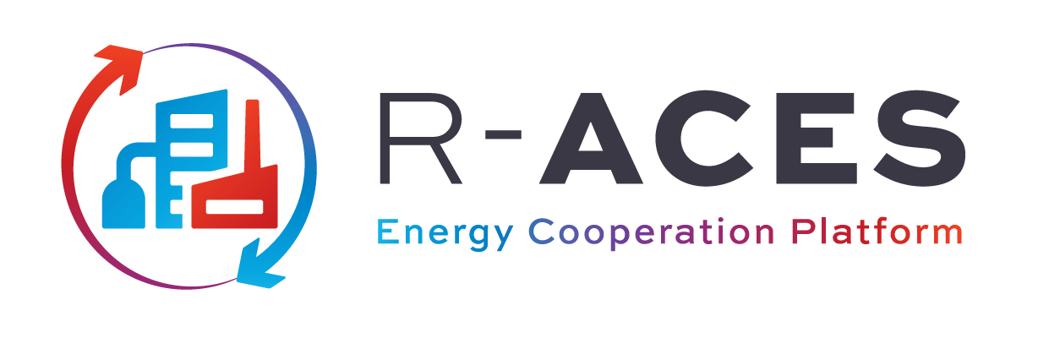
Authors: Uco Joustra, Malin Andreasson, Rene van der Vegt
date: 03.06.2021
This project has received funding from the European Union’s Horizon 2020 research and innovation programme under grant agreement N°892429

R-ACES Guide to Contract Template

Inhoud
1 General principles of EU Electricity law 3
1.1 Unbundling 3
1.2 Free choice of supplier 3
1.3 Designation of system operators 3
1.4 Third-Party Access (TPA) 4
1.5 Tariff Regulation 4
2 Exemptions Electricity 5
2.1 Direct lines 5
2.2 Closed distribution system 5
3 Licensing (Electricity Directive) 7
4 Heat Supply (no EU law) 8
4.1 Supply of heat (district heating) 8
4.2 Why heat supply is not regulated by EU law 8
5 Comparison of electricity and heat supply 10
5.1 Network regulation (Unbundling, TPA and tariff regulation) 10
5.2 Competition 10
5.3 Potential future changes 10
6 Annexes 12

Introduction
This Guide provides explanatory notes to the R-ACES contract template. Together the Guide and the Template form a practical and simple-to-use legal tool to support regions and organizations to decide on the required legal framework for the supply of energy in their energy cooperation.
The Template can be used as a starting point to develop a solid agreement. For more complex agreements the Guide offers a number of additional clauses.
The Template has been designed with three types of agreements in mind: District Heating, Solar and New Projects. The distinguishing features for the three types are:
- District heat: volume and profile are determined by Buyers requirement. Price is usually indexed and set periodically. Typically agreements are renewed annually.

- Solar: volume and profile are determined by Seller’s solar production. Price is often linked to a reference price. The agreement is usually for a fixed duration and special clauses are required to cover changes in subsidies and taxes.

- New Project: usually includes minimum annual volumes to guarantee cash flows. Pricing can be quite complex and payments are due in case of early termination. Typically these agreements are for a longer duration, and delivery and acceptance sometimes require a detailed scheduling process.
The Template can also be used as a basis for other agreements than the types listed above. The Template has been designed for Business to Business transactions. The user should be aware that household consumers usually have additional protection under EU laws.
The Template has three main parts:
- Articles 1 – 7 describe the normal process of the energy delivery and payment. If everything goes according to plan, these are all the sections that are actually being used.

- Articles 8 - 12 concern resolution of issues with the delivery, pricing and external developments. These Articles describe how to resolve the issue, the rights of each party and the financial consequences.

- Articles 13 -19 provide more or less standard legal and credit arrangements.
To promote standardization this template strives for alignment and sometimes uses identical concepts or wording as found in other generic templates.

How to use the Template
The Template can be used instantly by
- selecting the appropriate default clause by ticking the box [ ],
- completing details in the blanks [●],
- If required copying specific additional clause from the Guide to the Template; and
- attaching the relevant Annexes.
The Template is generic and uses the defined terms Energy and Unit. For specific energy and units you would have to do a ‘Find and Replace’. I.e. if the agreement is for Electricity then replace Energy with Electricity and Unit with kWh or (MWh).
Annex 1 contains the definitions and some interpretation rules. Some defined terms, like Buyer Annual Volume, have abbreviations: “BAV”. These are used in mathematical formulas to exactly define the calculations in the Template. In this way any ambiguity, sometimes present in plain language, is avoided.

Template key assumptions
Risk allocation: The Template is balanced in terms of risk allocation, without onerous conditions on either side. It assumes a Seller and Buyer of equal standing, unlike the implications of a Supplier and Customer sometimes seen in district heating contracts. Grace periods (to remedy breach of contract) have been set quite strict to ensure that the other party responds timely.
Delivery: The Template does not cover physical transfer of Energy as is the case in delivery of biogas or steam. For those type of agreements quality specifications needs to be defined, and the consequence of not meeting these specifications should be addressed.
Supply only: The Template covers the supply of energy. Joint development and joint investments, cost sharing or cost recovery are typically arranged in other agreements. For details, please see section 3.
Network: The energy is delivered through a system including network and connection. The Template assumes that connection has been installed and will be the contractual delivery point. The Template further assumes that the Seller is the operator of the network and there is no separate network operator. See more background and examples on networks in section 4.
The Template has no specific clauses relating to compensation for installation and/or usage of the connection other than the potential to add a fixed fee in paragraph 3.2.
Laws and Jurisdiction: The Template has been written with common legal principles of the EU in mind. As the Template is developed for Business to Business, consumer protection under EU law is not covered. Also network and access regulation is assumed not to apply. Section 4 gives a high-level overview of the EU laws that could potentially apply to the Template. Also, specific national legislation could apply, especially in the area of district heating.
Technical appendices: The Template covers the basic legal framework for the supply of energy in an energy cooperation. In some cooperation’s a large number of technical details would also need to be specified. Such details can be attached to the template in various appendices. In case of waste heat recover the ReUseheat project and the deliverable “Efficient Contractual Forms and Business Models for Urban Waste Heat Recovery” provides a good overview of some of the technical details [link].

Market Structure: The Template covers the agreement for the supply of Energy from the Seller to the Buyer. The actual market structure for the energy cooperation as a whole may be such that there are many similar agreements. In most cases the Template can be used. The table below gives an overview of the 4 major market structures.
Market Structure | Schematic | Description | R-ACES Template | Example
Bilateral  “1-to-1” | 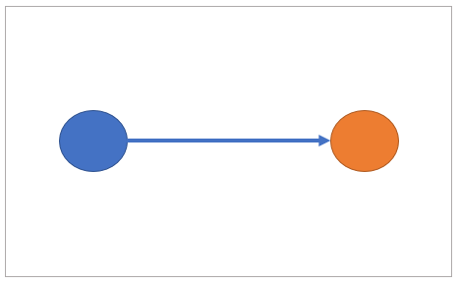 | Direct bilateral contract | Template can be used | Solar PPA between two parties
Tree  “1- to-many” | 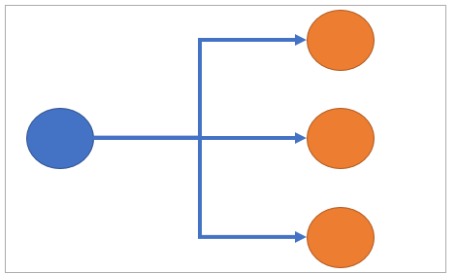 | One supplier to multiple customers | Template can be used | H₂ plant to multiple customers
Single Buyer  “many to 1 to-many” | 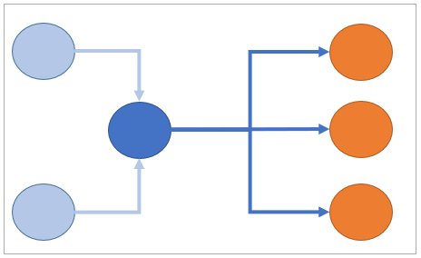 | Many suppliers to Single Buyer who sells to many customers | Template can be used | District heating company that buys heat from Data centers
Multiple Suppliers  “many to many” | 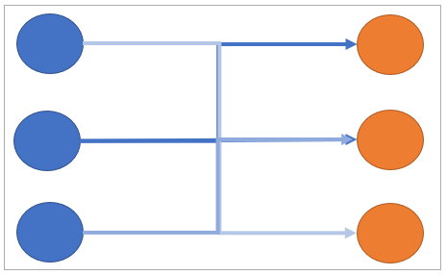 | Multiple suppliers to multiple customer | Template needs expansion with allocation and balancing | Trading and Supply at national TSO systems, including balancing and allocation rules

Single Buyer: Some District Heating networks may serve several suppliers of Heat. In these cases, usually the largest supplier acts as a single buyer and buys the heat from the other suppliers (e.g. waste heat from a datacenter) and sells it on to the customers. The Template can be used for both selling and buying of Heat by the single buyer. The Heat prices may differ to cover transmission losses and other costs that the single buyer incurs.
Multiple Suppliers: In case an energy cooperation envisages multiple Suppliers delivering simultaneously to multiple Buyers, a number of additional issues have to be addressed. These include the allocation rules of deliveries at the connection point and the balancing risk. Such a system can become quite complex and is beyond the scope of the Template. In case this is of interest, we suggest looking at the contract structure and network codes of Network System Operators (TSOs / DSOs). They cover the relevant aspects as nomination, allocation, reconciliation, balancing, and pricing.

Relationship between the Template and Investments in Energy Cooperation
Energy exchange projects are often developed by a consortium, willing to invest in production facilities, networks and connections, and/or end-user-installations. Such a project may be driven by numerous business, environmental, and regulatory considerations and can be supported by various legal structures and arrangements. This section of the Guide provides guidance and information on how these joint investments may link to the Template.
The legal structure can vary. It may include a new legal entity (i.e., an incorporated entity with shareholders that carries out the investment and sales). It can also have the form of a cooperation agreement (i.e., parties agree to cooperate and one of the parties is designated as the operator who does the investment, maintenance and sales on behalf of all partners). The “Guidance on contractual issues for joint services and energy cooperation” of the S-PARCS project provides some additional information on this topic [link].
This Section assumes an incorporated entity with a Shareholder Agreement (usually in conjunction with the Articles of Association) but the same principles apply in case there is no legal entity and the investors use a cooperation agreement.
A capital investment project is normally based upon the expectation of long term cash-flows from supply agreements, to recover the investments. Most likely, the participants will sign long term supply and transport contracts with the new legal entity, creating a guaranteed cash-flow. The Template can be used for these supply agreements particularly through expansion of the Articles on Annual Volume (paragraph 2.3), Price (art.3) and Term and Termination (art. 5).
Correspondingly, the shareholders must agree between themselves to keep the facilities in operation for the duration of the supply agreements.
It is customary to split the two roles, the role of investor and the role of buyer, into separate agreements. This makes the purpose of each agreement much clearer and easier to understand. The Template covers the supply agreement between the new legal entity and the Buyer and the Shareholder Agreement covers the investment. The split also makes it easier to use the supply agreement for a new customer (D in the figure below) who participates in the offtake of Energy but not in the investment. It also makes it easier to assign the shareholding in the asset separately from the supply agreement.
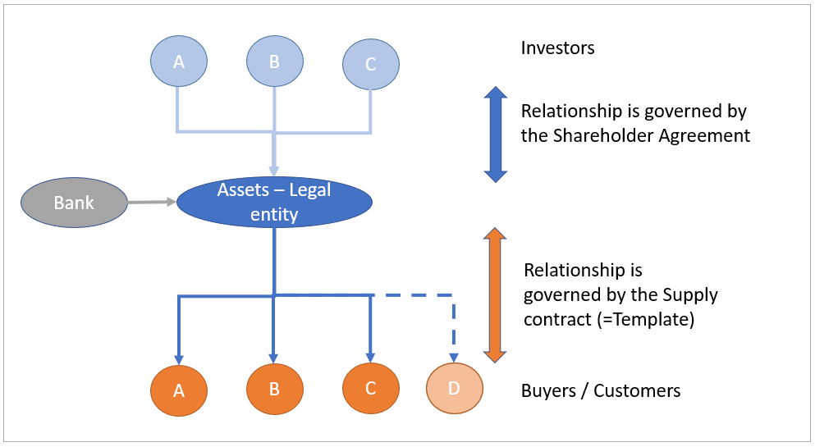

Shareholder Agreements
Shareholder (and also Cooperation) Agreements are usually project specific. These types of investments are often structured through a separate legal entity, whose shares or membership interests are owned by the major participants. The agreements usually cover the following matters:
Investment plan, business plan, financing plan. The plans for the project form the basis of the cooperation and will be agreed by the participants up-front. It will cover both the development phase and the operational phase. If project financing is required, the lender will require priority collateral rights over the assets, and over any forward cashflows (i.e. supply contracts, subsidies) which need to be separated for the lender.
Ownership and Governance. The new entity will probably own the assets. The shareholders will normally also share in the risk and reward and have voting rights in the general meeting pro rata their contribution. A day-to-day management should be established with appropriate mandate. Participants should be able to join and leave the consortium under pre-agreed conditions.
Compliance, Taxation, Accounting, Subsidies. Typically, these cooperation projects are not prohibited under competition laws (anti-trust rules) but prior assurance is advised. If the cooperation includes the development of a network that is potentially regulated then a waiver for network-rules may be useful (see EU section on networks). Fiscal and accounting matters often drive the structure, for instance whether the structure should stand alone, or consolidated with the shareholder accounts and fiscal returns. Subsidy application and usage, if any, should be agreed upfront.
Additional information can also be found in “Guidance on contractual issues for joint services and energy cooperation” in section 5 and Annex 1. [link to document of S-Parcs project]

Implication for the Template
There is a potential conflict of interest between the role of investor and the role of Buyer. For example, if the Energy becomes too expensive the Buyer may want to terminate the Supply contract. But then the investment may be impaired as the sales and future cashflows are reduced. It could also be the case that the Asset requires maintenance or reinvestments. If one of the investors refuses to take part, it may endanger the continuity of the Asset and the supply of the Energy. The potential commercial and legal implications and solutions can be very complex and are beyond the scope of the current Template.
However, there are several generic ways in which it may be addressed. First of all, it should be determined whether the investors are expected to remain Buyers in the long term. If so, the Agreement for Sale and Purchase of Energy and the Cooperation agreement can be linked through, for instance, the following clauses.
Cross Default Clause: Basically, this links the two agreements, the energy supply agreement and the cooperation agreement. If a party defaults under one of the two agreements, this counts as a default under other agreement, and the latter may terminate. The defaulting party may have to pay a specific termination amount as included in the agreements.
Material Reason: The energy supply agreement can state that if the cooperation agreement is terminated, this qualifies as a material reason for the Buyer and that the Seller should pay an appropriate Termination Amount. I.e. if an investors wants to terminate his participation in the cooperation agreement he may have to face the pay out of a termination amount.
In general, as it is preferable that investment and Buyers/Sellers role can be disconnected, the predictability of the cash-flows from the supply agreement is increasingly important. As explained in the general part of this Section 3, this can be addressed in the articles on Annual Volume (paragraph 2.3), Price (art.3) and Term and Termination (art. 5) of the Supply Agreement.

Guidance on EU laws
The relevance of EU law to the Template depends on the Energy supplied. While there are laws at the EU level that regulate Electricity and Gas supply, there is no dedicated EU law pertaining to Heat Supply. Most Member States have national laws governing the supply of Heat. These national laws are to some extent based on the principles of EU Electricity and Gas laws.
The core of the EU Electricity and Gas legislation is a market-based system and the principle that networks are natural monopolies. As networks are natural monopolies, they should be unbundled to avoid any conflict of interest between network operators and producers, suppliers and customers. Anybody should be able to access a network (Third Party Access (TPA)). Networks have regulated tariffs and are licensed by the regulator.
For Suppliers the key benefit of a market-based system is that they can charge the price that they want, the key benefit for customers is that they can choose their supplier. For household customers some additional protection applies.
An energy cooperation usually involves either direct lines or a closed distribution system. These can be exempted from some of the rules in EU Electricity and Gas legislation, which is useful amongst others with regards to TPA rules. An exemption may be useful as it reduces the administrative burden and provides more contractual security. It is not recommended to restrict TPA to the system unless there is a technical reason or capacity restraint, as access restrictions are often opposed by regulators.
District heating and cooling is not regulated at the EU level as such systems operate as “isolated islands” with very limited interconnections. Heat supply is thus regulated at Member State level, and national Heat (supply) laws usually cover tariff setting, and sometimes TPA mechanisms. In the EU Renewable Energy Directive there are also certain obligations on the supplier to provide information to their customers.
Another important aspect is supplier licensing. Supplier licensing is determined at Member State level and is usually also linked to tax rules. In some cases, even in a closed distribution grid, the seller could still be considered a licensed supplier with certain obligations amongst others for invoicing. For protected customers (i.e. households) then the rules in general, and the licensing rules in particular, become stricter.
In major projects REMIT (transparency) might be relevant for large electricity connections.
More information on the EU law can be found in the Guide to EU Law [Link]

Key Topics
The table below contains an alphabetic overview of the key topics covered with links to the Guidance notes and Template clauses {[To be expanded, and Links to be added in the Website environment]}
Topic | Links
Annual Volume
Credit
EU law
Exclusivity
Interruption
Investments and Payback
Lock in
Price and Pricing
Regulator
Term and Termination
[to be expanded]

Guidance notes for the R-ACES Contract Template

Article 1. Parties, Definition and Scope
Article 1 is a generic introduction to the agreement, defining the parties involved, conventions used and stating what the agreement is about (scope). Definitions and interpretation rules can be found in Annex 1.
In this Template, the Parties can sign on the first page, which avoids having to copy their details to the last page, where, conventionally, signatures are located. Users may want to move the names of the parties and the signature blocks to the last page. On each page two dotted lines at the lower left-hand and right-hand corner are available for initialing, which helps identifying the final agreed document.
Exclusivity: If, by way of example, Buyer takes all the electricity produced by Seller’s roof-top solar panels, the agreement is exclusive. This should be mentioned in the Scope. Otherwise, it is rare that sellers have restrictions on choosing their buyers, and vice versa. Exclusivity clauses are not recommended as they are sometimes looked upon unfavorably by regulators.

Article 2. Energy, Profile and Volume
Article 2 is about the type and volume of Energy delivered. Delivered and Acceptance (Transfer) will be at the Delivery Point. For District Heating this is usually the heat exchanger where the energy is transferred and measured. For Electricity the delivery point is usually the measuring point.
The time intervals (“Scheduling Period”) used to measure the Energy are stated in paragraph 4.2. For Electricity this is usually 15 minutes, for all other energy 1 hour.
An important choice to be made for the profile of the Energy delivery. There are three default cases:
- Under the ‘As measured, Buyer driven’ option, the Buyer takes the amount of Energy that it requires. This is typical in the case of Heat Supply, where the amount delivered is determined by the business processes of the Buyer and ambient temperatures.

- Under the ‘As measured, Seller driven’ option, the Seller determines the amount of Energy that is delivered. This is typically the case for Solar Production where the Seller delivers all produced electricity to the Buyer.

- Under the ‘Scheduled’ option: In some case, e.g. district heating supply, the Seller wants to know how much Heat is to be supplied the next day. In case of high demand Seller may need to turn on additional boilers. In such a case the Seller and Buyer may agree that the Buyer has to give a forecast each day of the expected demand for the next day. In the Scheduling procedure the Parties can then agree how strict this Scheduling process is, e.g. with or without confirmations or rights to deviate from the agreed schedule. The scheduling process can also include compensation payment schemes if a Party does not adhere to the agreed schedule. Potential production, transport or consumption restrictions have to described. Generically these types of Scheduling process are used by national Electricity and Gas TSO’s to ensure their grids are in balance.
In cases 1 and 2 above there is no need for any explicit Scheduling. The meter measures the actual flow of the Electricity or Heat and that is the Contract Quantity that is delivered.
The Parties may agree a Minimum Annual Volume. Usually this is to guarantee the Seller a minimum amount of revenue per year. There are three default options:
- None: No volume restrictions apply. The implication is that the Seller has no guarantee on the sales volume and thus no contractual guarantee on cash flow.

- Buyer: Buyer commits to offtake a certain volume. If Buyer takes less than the minimum annual volume, Buyer must pay in full or part for the volume not delivered, i.e. pay for The Minimum Volume minus the Delivered Volume too.

- Seller: Seller commits to deliver a certain volume. If Seller delivers less than the minimum annual, Buyer has the right to compensation to cover the costs of acquiring/generating the missed volume of energy. For Electricity, such compensation is usually linked to a market index.
In very rare occasions both Buyer and Seller volume commitments apply.
The maximum capacity of the energy delivered per Scheduling Period (usually hour or 15 minutes) is determined by the technical maximum capacity at the connection / metering point. This maximum is defined in paragraph 2.2 and determined by the connection and metering capacity. Usually, no compensation applies for deliveries above the maximum (additional volume is paid for at contract price).

Article 3. Price
Articles 2 and 3 form the core of the Template. Articles 2 covers the volume and Article 3 the price. Together with the Term of the Agreement (Article 5), Articles 2 and 3 determine the total value of the Agreement.
The pricing mechanism very much depends on the type of energy supplied and the overall size of the energy cooperation. The Template provides a choice for the 3 most common options:
- Fixed price: For short term duration contracts usually, a fixed price is agreed. Optionally the fixed price can be adjusted for inflation using an agreed inflation index (e.g. Consumer Price Index).

- Indexed price: for electricity supply (e.g. from solar panels), it is customary to link the price of the electricity to the market price. In almost all EU Member States there are well established electricity markets that have hourly and daily prices. In such case it is logical to use the market as an index for the price of electricity. For Heat contracts the Energy Price is sometimes linked to the Gas price (as competing costs of heat). In most cases the Multiplier is 1.
There can be a surcharge or a discount depending on the specific circumstances. A surcharge may reflect additional costs that the Seller has incurred, or a discount may reflect specific subsidies that are granted to the Seller.
The generic formula reflects the possibility of a surcharge or discount and it is up to the parties to agree the height and/or inflation correction.
- Set Periodically: In some district heating contracts the Seller is allowed to recover incurred costs based on specific rules. Such rules usually state which costs are allowed to be recovered and make a distinction between direct and shared (or common) costs. Reimbursable costs may also refer to grid losses, specific taxes, CO2 credits, depreciation periods, return on invested capital and subsidies etc.
In some cases, the Seller is (semi) regulated and there is a specific regulatory authority that checks if the Price is in line with all the rules and regulations for the supply of Heat. In such case the contractual Price can be set periodically by the Seller as long has the Seller has approval from the regulatory authority. In the latter case, no detailed costs allocation scheme is necessary for the contract.
Pricing formulas can become very complex, depending on the scale and complexity of the contract.
Parties may also agree a Fixed Monthly Fee; Typically, this happens in some District Heating contracts to cover fixed costs for the connection.
In case of a separate network operator the following clause can be added to Article 2. Each party pays his fee directly to the network operator
2.4 The Energy will be delivered via network [..]. Each party is responsible for his own connection to the network and concluding a capacity agreement with the network operator.

In case the Seller is the operator of the network and a separate network fee is due the following clause can be added. It can be either a fixed fee of a capacity based fee:
3.4 Network fee
In addition to any other amounts due under this Agreement, Buyer is liable to pay to Seller the Network Monthly Fee.
[ ] The Network Monthly Fee (“NMF”) is [●] €/Month.
[ ] The Network Capacity Fee (“NCF”0 is [●] €/Unit/Scheduling Period/Month
[ ] as of 1 January each year, the price is corrected for inflation. The inflation index used is [●] with [●] as Base Year.
The Annual Volume Make-up Fee is linked to the minimum annual volume. If the Buyer fails to take the annual volume to which it has committed (the Buyer Annual Volume), then the Buyer pays a compensation to the Seller. In the Template the compensation (make-up fee) is a percentage of the average price times the shortfall (the BAVMF). Obviously, there is no compensation due to the extent the shortfall is caused by failure of the Seller to deliver. Likewise, if the Seller fails to supply the annual volume to which it has committed (the Seller Annual Volume), then the Seller pays a compensation. In the Template the compensation (make-up fee) is a percentage of the average price times the shortfall (the SAVMF). Obviously, there is no compensation due to the extent the shortfall is caused by failure of the Buyer to accept. The SAVMF formula has a negative sign, as this is a credit to the Buyer.
The formula for the make-up fee is not very detailed. In some instances, parties want to elaborate on allocating the financial consequences of shortfall, like factoring in the causes of unavailability on both sides, and/or in shorter time intervals.

Article 4. Schedule, Delivery and Acceptance and Measurement
This Article specifies that Seller shall deliver the Energy at the Delivery Point and Buyer shall accept the Energy at the Delivery Point. Interruptions and risks before the Delivery Point are for account of Seller, and Interruptions and risks after the Delivery Point are for account of Buyer.
In most cases the Measurement is relatively simple. Key is to state who is responsible for the measurement installation and actual measurements. The measurement installation should be described in Annex 2. Additional detail can be added on the timeframe and format of the sharing of Measurement. Elaborate contracts may describe the calibration methods for the meters, and how to allocate discrepancies.
Article 4.2 defines the Units of measurement and the Scheduling Period. The actual measurement (in Units) over a Scheduling Period is defined as a Contract Quantity. The aggregate of the Contract Quantities is used for invoicing and for determining the Make up Fees.
Potentially the definitions may need to define the standards at the delivery point, e.g. for Electricity that could be Voltage and Frequency, for heat it could be water temperature going in an out.

Article 5. Term and Termination
The Template provide two options for the term of the Agreement:
- Fixed Term: The agreement runs from the Effective Date until the Expiration date defined here in Article 5. It is expected that Parties will discuss and potentially agree renewal before the Expiration Date, absent which the agreement will terminate on the Expiration Date. There is sometimes a difference between the Effective Date (from which the agreement takes effect) and the date of signing (placing the last signature on the document). Delivery may have started before all contract details have been put on paper, or the contract may have been signed well in advance of actual delivery. This explains the two terms: Signing Date and Effective Date.

- Annual renewal: The agreement is effectively an evergreen contract, i.e. it has no fixed Expiration Date, but each Party has the right to end the Agreement by giving formal notice 2 months prior to the 31 December. If notice is given, the Agreement will end at 31 December.
In absence of a minimum annual volume, either party can stop the delivery, de facto ending the relationship. Nonetheless it is advisable to agree an initial term of the agreement. Before the end of the term, the parties should discuss renewal.
A cross reference is made to Article 11 that sets out how the Agreement is terminated in special circumstances, for instance if one of the Parties does not perform its obligations. Compensation may be due in such cases.
Sometimes long term contracts and a minimum annual volume are required to cover significant investments. Long term contracts are typically not permitted for sales to household customers, and regulators may query whether the term is indispensable. Please also refer to the chapters on Renegotiation and Hardship in this Guide on Article 11.

Article 6. Invoicing and Payment
Invoicing and Payment is on a monthly basis after the month of delivery. Payment terms are similar to those in the EFET master agreement, i.e. payment on the 20th of the next month.
In principle the Buyer pays for the actual measured quantities. If these are not yet available at the time of invoicing, then payment is based on an estimation.
If Set-off/Netting of amounts payable and amounts receivable under this agreement is important and parties want to permit it then the following clause can be added:
6.6 Payment Netting
If the Parties are each required to pay one or more amounts in the same currency (for which purpose all EURO currencies shall be considered a single currency) in connection to this Agreement, then such amounts with respect to each Party shall be aggregated and the Parties shall discharge their respective payment obligations through netting, in which case the Party, if any, owing the greater aggregate amount shall pay the other Party the difference between the amounts owed.
The Default Interest rate is often defined as a bench mark rate with a markup.
For disputed invoices party can either choose for the principal that Invoices are paid in full or only for the undisputed amount. After the dispute has been settled the interest on the difference will be payable.

Article 7. VAT and Other Taxes
First of all, this Article provides standard arrangements for VAT. The default assumption is that VAT is payable for the delivery of energy. In some very specific circumstances, no VAT is payable. In such cases the following clause could be used:
Where, in accordance with EU and/or national legislation, any supplies may be Zero-Rated and/or subject to the reverse charge in accordance with Articles 38, 39 or 195 of Council Directive 2006/112/EC, the following shall apply:
(a) the Buyer and the Seller hereby covenant that they will do all such proper acts, deeds and things as are necessary (which may include and shall not be limited to providing to the Seller all such proper, true and accurate documentation or assistance as may reasonably be required by the relevant taxing authority) to ensure that such supply is Zero-Rated or subject to the reverse charge for the purposes of such legislation;
(b) in the event that the Buyer or the Seller fails to comply with such obligation, the non- complying Party shall indemnify the other Party in respect of any and all VAT, penalties and interest incurred by the other Party as a result of the non-complying Party's failure to comply with the above covenant; and
(c) in the absence of the Buyer providing any documentation as referred to in (a) above, the Seller reserves the right to charge local VAT
Definitions
“Zero-Rated” means, in respect of a supply, a tax exempt export or tax-free export under applicable VAT Rules and “Zero-Rating” shall be construed accordingly.]
In most countries Other Taxes apply to the delivery of energy too. For example, in the Netherlands the supplier has to charge “Regulerende Energie Belasting” and “Opslag Duurzame Energie”. It very much depends on the specific jurisdiction and the legal status of the Seller whether or not these taxes have to be charged. Note that in most case the Buyer also consumes the Energy, so it is unlikely the Buyer will be able to pass any of these taxes on to a third party.
Critical area is the renegotiations right in case of a New Tax; The default option in the Template is that if the New Tax is more than the equivalent of 5% of the Energy Price, then then newly taxed party has the right to seek contract renegotiation. Parties can also agree on a different threshold, may decide to share the risk equally or agree termination rights.
A withdrawal of a Subsidy has the same material effect as the introduction of a new tax. When signing the contract, the parties should agree to which subsidies are applicable to either Buyer or Seller in the Representations and Warranties section. If such a subsidy is then withdrawn, this could lead to a renegotiation.
A similar principle can be applied to the withdrawal of any subsidies which apply to the delivery of the Energy.

Article 8. Remedies for Failure to Deliver and Accept
Up to this Article 8, the agreement has defined what happens in the normal course of events. The next articles are about what happens if something does not go as originally planned.
Article 8 is used if Parties are scheduling on a daily basis (Article [2.2]) and one of the parties causes the energy delivered to deviate from the agreed schedule. In case of scheduling Gas or Electricity with a TSO, such a deviation is called an “imbalance” and a TSO normally has a penalty scheme for such deviations.
The leading principle is that the agreed price for the delivered energy is paid. In addition, if a failure of party has caused a mismatch between the scheduled energy and the actual delivery, then the Party that has caused the failure has to compensate the other.
If parties agree to ‘as Measured’ in paragraph 2.2, then there is never a failure to deliver or accept. In other words, for this Article to have any effect Parties have to agree to ‘Scheduled’ and intend that failure to adhere to the agreed schedule has consequences written down in Article 8. So, if Parties agree to “as Measured” this article can be deleted.
If deemed necessary, the following clause can be added to explicitly state that each party is responsible for arranging his own back and that there is no additional liability on the other Party other then stated in 8.1 and 8.2.
8.3 Complete Interruption of delivery and acceptance
Both parties must be able to withstand complete failure of delivery and acceptance, respectively.
The Buyer is responsible for alternative source of Energy in case of failure to deliver and the Seller is responsible for the disposal of Energy in case of failure to accept. There is no liability other than stated in 8.1 and 8.2.
Any payment obligation resulting for failure to Deliver or Accept are included in the regular invoicing and payment process.
Note that this article does not relate to minimum annual volume (if any). This is covered in Article 3.3.

Article 9. Force Majeure
Force Majeure are events beyond their reasonable control that release Seller from its delivery obligations or release Buyer from its acceptance obligations. This clause is only relevant if there are firm delivery or acceptance obligations.
In some countries, e.g. the UK, it is customary to make a long list of all events that are considered Force Majeure. The list can be limitative meaning that if something happens that is not included in the list then it is not considered Force Majeure. Or the list can give examples, so that there is more clarity what can constitute Force Majeure. In other countries it is customary to refer to the article in the law and rely on common interpretation of the law, or refer ultimately the courts.
In an ‘as measured’ contract, the article has no impact as there are no delivery and acceptance obligations. If there are no Annual Volume obligations also this article has no impact.

Article 10. Suspension of Delivery
The leading principle is that if the invoices are not paid on time the Seller has the right to suspend delivery after written notice and a [10] day grace period in which the Buyer can pay the overdue invoice.
The Template is designed for Business to Business transactions, but is should be noted that in supply agreements with households, consumer protection may apply, and that the Seller cannot just stop delivering heat.

Article 11. Termination for Material Reason
Article 5 provides for ordinary termination of the agreement, as elected at the end of its term, or by notice. In exceptional circumstances, like failure to pay the invoices, a party may terminate the agreement with immediate effect. Article 11 determines under what conditions a Party can terminate the Agreement for this and other ‘Material Reasons’.
Paragraph 11.2 lists 5 categories of Material Reasons:
- Failure to Pay
- Bankruptcy
- Failure to adhere to the agreement
- Prolonged Force Majeure
- Misrepresentation
This Article (Termination for Material Reason) is designed to protect Parties under long term contracts particularly. Under such contracts it is customary that the Seller wants to ensure offtake by the Buyer and that a minimum annual volume must be taken by the Buyer securing a minimum revenue stream for the Seller. If the Seller suffers from a Material Reason (e.g. the Buyer is in Force Majeure or does not pay) then the Seller can terminate the Agreement and claim a Termination Amount from the Buyer to compensate for the future loss of revenue. The template sets the termination amount on a percentage of the future cash flow. Parties can replace this with other calculation methods. More complex Termination Amount calculations can be agreed upon for specific contracts, including links to investments, costs, returns etc.
It is also possible that the Buyer terminates for Material Reason, for instance prolonged non-delivery. Then the Buyer may be entitled to a Termination Amount.
NOT included as Material Reason are commercial reasons. For instance, if the price is too low from a Sellers perspective. Sometimes parties agree a renegotiation or hardship clause for such events. This is discussed below. Equally NOT included in the list is termination because a Party closes down the site and stops it activities. In such a case the Party may still be obliged to pay a Termination Amount under 11.3. If Parties want to agree that closing down a site is a valid Material Reason then they should include this in paragraph 11.2 or in Article 5 (Term and Termination).
Hardship clause: During Long term contracts the commercial circumstances may changes significantly. A Party may want to terminate the agreement but is prevented to do so. This is sometimes referred to as a “Lock in” situation.
Often a balance must be struck between the need for a long term contract to recover investments, and the inevitable uncertainty about what the future will bring, and whether the agreed terms still make sense in the future.
To cater for this uncertainty sometimes a long term, minimum volume contract contains a (price) renegotiation or hardship clause similar to the one below. Note that Article 7 on Taxation has a somewhat similar clause for renegotiation in case of material changes in taxation:
At any time after [●] yeas after the Effective Date, either Party may request renegotiation of the terms of this Agreement if economic conditions, external to the Party requesting the renegotiation, have changed significantly, distorting the economic balance of the Agreement existing between the Parties at the Effective Date and causing a Party to suffer substantial commercial losses under this Agreement. Such renegotiation must be conducted in good faith with a view to restoring such economic balance, but does not oblige a party to accept a loss making position.
Obviously, the value and effect of such a hardship clause are difficult to quantify at the outset, and the clause may not be enforceable in practice or at law.
In the Template the Termination Amount is determined by a formula. Alternatively a table for the Termination Amount based on the year the contract is terminated cab be used. The clause could then be :
Calculation of the Termination Amount
In case the Seller is the Terminating Party then the amount (the “Termination Amount or “TA”) to be paid in accordance with paragraph 11.1 (Termination for Material Reasons) shall be based on the year of termination according to the following table:
Year of Termination | Termination Amount (Euro)
2022 | [ ]
2023 | [ ]
2024 | [ ]
2025 | [ ]
2026 | [ ]

In case the Buyer is the Terminating Party then the amount (the “Termination Amount”) to be paid in accordance with paragraph 11.1 (Termination for Material Reasons) ) shall be based on the year of termination according to the following table:
Year of Termination | Termination Amount (Euro)
2022 | [ ]
2023 | [ ]
2024 | [ ]
2025 | [ ]
2026 | [ ]

Article 12. Index Prices and Alternatives
If the agreement is based on an Index Price some arrangements have to be made on what to do if the Index in discontinued. An index can disappear if two market areas merge or if a commercial journal or governmental entity no longer publishes the index price.
Parties can agree on alternatives at the time of signing the agreement by filling in the alternatives in 12.2 or they can renegotiate at the time the index disappears
This article is only needed in case of an index price is used, or a price is subjected to an index for annual indexation. If not, the article can be deleted.

Article 13. Limitation of Liability
As customary, liability is limited as far as reasonably possible. Seeking financial compensation (liability) is not a recommended cause of action if the agreement does not deliver what was expected on either side.
Compensation for failed delivery is not covered by this limitation and should be settled according to the Article 8 of the Agreement (Remedies for Failure to Deliver and Accept).
Liability for intentional default or fraud is not limited either.
Each party has a duty to mitigate its losses.

Article 14. Guarantees and Credit Support
The Template clause is primarily written from the Sellers perspective. It is quite generic and can be elaborated further.
The clause allows the Seller to take action if something occurs which could ultimately affect the ability of the Buyer to make payments and thus the Agreement.
Obligations to inform each other on the financial well-being may be included. In case there is a deterioration then a Party can demand additional security under the MAC clause.
In some long term agreements, the Buyer may also want to ensure the financial stability of the Seller. The clause can then be made symmetrical by replacing Seller with “Party” and Buyer with “Other Party”.

Article 15. Confidentiality
This is a standard clause obliging the parties to keep the terms of the agreement confidential. Note that limited disclosure of data regarding Quantities, Specification, Delivery Profile is permitted for usage by the de facto network operator of the system connecting Buyer and Seller (paragraph 15.2 (e). This can be deleted if not appropriate.

Article 16. Assignment
This standard contractual wording governs the potential transfer of the agreement by the Seller or the Buyer to another party. Such consent shall not unreasonably be withheld. Assignment to group companies of equivalent creditworthiness is permitted without consent.

Article 17. Representations and Warranties
These are standard contractual arrangement protecting both parties equally. In practice it may also serve as a check list for both parties.
Note that if a Party is in breach of this clause, it is considered a Material Reason under Article 11, and the other Party has the right, but not the obligation, to terminate the agreement.

Article 18. Governing Law and Dispute Resolution, Expert
The default provisions in this Article assume that users want the laws of the Delivery Point to apply, and want any disputes that cannot be resolved amicably to be decided by the courts of the Delivery Point, and that some matters of technical nature, like measurement issues, are expeditiously and final resolved by an Expert.
Users can replace this Article with their customary wording, which is often more elaborate.

Article 19. Miscellaneous
The Miscellaneous Article adds certain standard general provisions to the Agreement. Parties may want to replace this with their own standard wording.

Disclaimer
This publication reflects only the author's view. The Agency and the European Commission are not responsible for any use that may be made of the information it contains.

Annexes

Annex 1: Project Summary

The R-ACES project is an initiative promoted by 7 partners from 6 European countries, with the vision to support high-potential industry parks and clusters to become fully fledged ecoregions that reduce emissions by at least 10%. R-ACES means a step-change in the contribution of European Industry to the climate targets of the EU. The industry sector after all represents 25% of all energy demand – and 50% of the total cooling and heating demand on the continent; yet only 16% comes from renewables. By focusing on collective measures and clustering, the efficiency of industry can be drastically increased.

The focus of R-ACES therefore is to turn high-potential, high-impact industrial clusters into ecoregions that achieve at least a 10% reduction in emissions. They do so by exchanging surplus energy, making extensive use of renewables, and tying everything together with smart energy management systems. An ecoregion is a geographic area where energy and information exchanges occur between various companies and actors to reduce waste and energy consumption. Ecoregion can be centred on an (eco-)industrial park or (eco-) business park, linked to its surroundings by a 4th/5th generation district heating/cooling network.

R-ACES is the capping stone, condensing the knowledge and experience gathered throughout EU and national projects into a set of three focused tools, namely a self-assessment tool, a legal decision support tool, and a smart energy management platform for clusters. The tools are embedded in support actions built around peer-to-peer learning, more formal coursework and webinars, and serious games. Together they enable a cluster to really become an eco-region and set up meaningful energy collaboration. The entire package of tools and support is aimed at the high-potential clusters identified in the European Thermal Roadmap. It will be validated in three eco-regions, actively deployed in another seven regions, and disseminated to identified ninety regions European wide. In addition, the tools and support methodology will be made available to third parties in a sustainable way after the end of this project.

Annex 2: Partners
https://ispt.eu/
https://www.condugo.com/
http://www.spinergy.it/
https://www.energycluster.dk/
http://www.energycluster.it/en
https://www.pomantwerpen.be/
https://www.esci.eu
https://www.euroheat.org/

